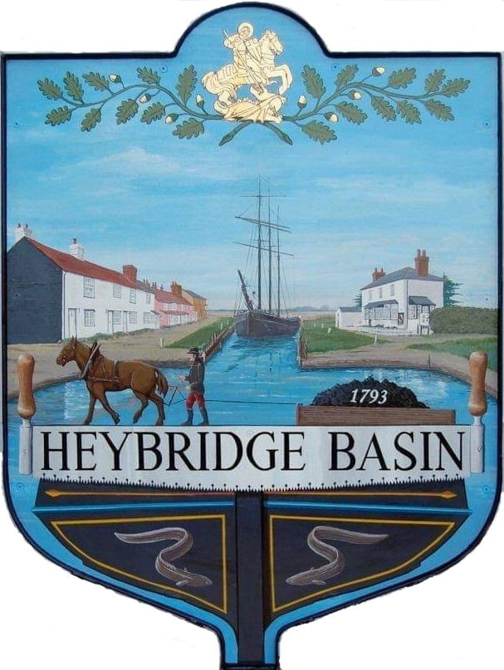

HEYBRIDGE BASIN PARISH COUNCIL

Minutes of the Annual Statutory meeting of Heybridge Basin Parish Council held on Tuesday 16th May 2023 at 7.00pm

Present – Cllrs M. Hodges (Chair), R. Bryson (Vice Chair), J. Sjollema, C. Edmond and M. Hobden.

Also present – G. Lake – Clerk and 1 member of public.

Recording of meetings
Please note, the Council may be recording any part of this meeting held in open session. Members of the public attending the meeting with a view of speaking are deemed to be giving permission to be included in the recording.

23/1 Election of Chair
- To elect a chair for the forthcoming year and to receive a signed Declaration of Acceptance of Office.
It was resolved to elect Cllr Hodges as Chair of the Parish Council for 2023/24
Proposed: Cllr Bryson
Seconded: Cllr Hobden
All agreed.
Cllr Hodges signed the Declaration in front of the Council and Clerk.

23/2 Election of Vice Chair
- To elect a Vice Chair for the forthcoming year and to receive a signed Declaration of Acceptance of Office.
It was resolved to elect Cllr Bryson as Vice Chair of the Parish Council for 2023/24
Proposed: Cllr Hobden
Seconded: Cllr Sjollema
All agreed.
Cllr Bryson signed the Declaration in front of the Council and the Clerk.

23/3 To receive Declaration of Acceptance of Office from all elected members.
It was noted that all elected members had signed their Declarations prior to the meeting in front of the Clerk.

23/4 Apologies for Absence.
- To received and accept apologies for absence.
Apologies for Cllrs Howat and Swann were approved.

23/5 Register of Members Interests
Councillors are reminded they need to complete their disclosed interests on the Maldon District Council on-line form if they have not already done so. Clerk reminds councillors that this should be updated whenever Councillors have an update at any time of the year but needs updating at least on an annual basis (usually in May) in order to confirm that all details are up to date.
Noted.

23/6 To receive Declarations of Interest in accordance with the Council’s Code of Conduct and with section 106 of the Local Government Finance Act 1992.
Members are reminded that they are also required to disclose any such interests as soon as they become aware should the need arise throughout the meeting.
Cllr Edmond – Non-Pecuniary Essex Waterways, Cllr Hobden – Non-Pecuniary HBSA, HB Rivercare and Basin Oars.

23/7 Public Forum (15 minutes)
No members of public wanted to speak.

23/8 To sign as a correct record the minutes of the full council meeting held on 25th April 2023.
The Minutes as previously circulated were agreed as a correct record.

23/9 Finance.
- To approve
- Payment requests for April/May 2023
The Payments as previously circulated were approved.
- Receipts for April/May 2023
The receipts as previously circulated were approved.
- Bank reconciliation as at 30th April 2023.
The Bank Reconciliation was approved.
- To consider renewal of membership with the Maldon & Heybridge Heritage Harbour Association at a cost of £20. It was resolved to renew the membership.
- To reaffirm signatories on the Council’s bank account and review if there is any need for any amendments. It was resolved to remove Cllrs Heubner and Schnurr and add Cllr Hobden.
- To appoint one member as Bank Verifier. Cllr Howat is the current Bank Verifier. It was resolved to defer this item to the next meeting, giving Cllr Howat the opportunity to continue.

23/10 Appointment of Internal Auditor
- To confirm that April Skies will continue to provide the Council’s Internal Audit. appoint
It was resolved to defer this item to the next meeting, once April Skies had completed the current Internal Audit, as this was the first year with this company.

23/11 Asset Register
- To review the Council’s Asset Register.
It was resolved to accept the Asset Register with the amendments of a typo and adding the bus shelter shelves and bench. It was resolved for the Clerk to liaise with MDC regarding how they value their car park land.
.
23/12 Insurance
- To consider quotes received for the renewal of the Council’s Insurance Policy and agree any action to be taken.
It was resolved to accept the quote from Zurich for a 3-year term not including the car park land.

23/13 Appointments of Committees, Working Groups and Representatives
- To consider appointments of members to serve on the Personnel Committee (3 minimum) and to approve the Personnel Committee Terms of Reference.
It was resolved to appoint Cllrs Bryson, Edmond, Sjollema and Hodges as members of the Personnel Committee. It was resolved to approve the Terms of Reference.
- To consider the membership of the Daisy Meadow Car Park Working Group and to confirm the continuation of Delegated Authority to the Clerk.
It was resolved that the DMPC WG would consist of Cllrs Bryson, Edmond, Hodges, Sjollema and the Clerk. It was resolved for the Clerk to continue to have delegated authority.
- To consider the membership of the On-Street Parking Working Group.
It was resolved that the On-Street Parking WG would consist of Cllrs Hodges, Bryson, Edmond and Sjollema.

- Any other committee or Working Group as considered appropriate.
It was resolved to discuss a working group for the village design statement and neighbourhood plan at the next meeting.
- To appoint one representative each to the following bodies:
- Maldon and Heybridge Heritage Harbour Association
It was resolved for Cllr Edmond to be lead representative.
- Chelmer Canal Trust
It was resolved for Cllr Hobden to be lead representative.
- Maldon and Blackwater Estuary Coastal Community Team
No representative appointed as they do not appear to exist.
- 20’s Plenty for Essex
It was resolved for Cllr Sjollema to be lead representative.
- Any other representative as considered appropriate.
There were none.

23/14 Policies and Procedures
- To review and agree the highlighted amendments to:
- Standing Orders
- Financial Regulations
- Co-Option Policy
- Complaints Policy.
It was resolved to approve the amended policies.
- To agree to the following policies reviewed by the Clerk:
- Press and Media
- Freedom of Information
- Data Protection
- Code of Conduct
- Risk Assessment
It was resolved to approve the above policies with the exception of removing the introduction to the Risk Assessment. It was resolved for the Clerk to ask the Internal Auditor about the Risk Assessment including more information regarding public liability.
- To review and adopt the following:
- Data Retention Policy
- Donation Policy
- Equality and Diversity Policy
- Health and Safety Policy
- Publication Scheme
It was resolved to approve the above policies. It was resolved for the Clerk to send the Newsletter to the British Library and Essex Records.

23/15 Action Plan
To review the Action Plan and agree any action to be taken.
It was resolved to approve the Action Plan.

23/16 Grounds Maintenance.
- To consider the quotes received for the Grounds Maintenance Contract renewal and agree any action to be taken. It was resolved to accept the 2 years and 10-month term quote from MDC.

23/17 DMCP
- To receive an update from the Working Group and agree any action to be taken.
Cllr Bryson and the Clerk were due to collect the dozen silver Birch whips on Thursday 18th May. The Clerk will chase SP for the installation of the new signs.
Cllr Bryson proposed to have an electrical examination of the island in the car park to ascertain how much power is there. It was resolved for the DMCP WG to organise the electrical examination.

- To consider the quotes received for works to the Leylandii in the access road and agree any action to be taken. It was resolved for the Clerk to liaise with the contractors who have quoted and ask for method statements, and that the DMCP WG bring a recommendation to the next meeting.

23/18 Bench near Bus Shelter
  - To consider the quote received to works to the bench and agree any action to be taken.
It was resolved to accept the quote from AP Maintenance for £130.00.

23/19 Planning Applications
- To consider any planning applications received after the publication of the agenda and to agree the action to be taken.

23/00444/WTPO – Tolcraft 104 Basin Road – Horse Chestnut – Crown reduction by 2.5m
It was resolved to recommend the granting of planning permission.

23/00448/PACUCD – Leanna House, Lock Hill – Conversion of existing workshop building to 2-bedroomed residential dwelling including internal and external alterations.
It was resolved to recommend the refusal of planning permission due to the loss of employment opportunity.

23/20 Schedule of Meetings 2023/2024
- To agree on the dates of Full Parish Council meetings up to and including the next annual meeting of the Parish Council. The proposed Schedule of Meetings for 2023/2024 were approved.

23/21 Clerk’s Report
- Coronation Plaque – It was resolved for the Clerk to order the blue plaque that members had seen online at a cost of £70.00.
- Timber Yard – Clerk informed members that the developers had invited the Council to a presentation meeting. It was resolved that the Council would not accept the invitation and would wait until a planning application has been submitted.
- Clerks use of DMCP – The Clerk had used the car park three times, twice for members to sign their Declarations and once to issue Agendas on noticeboards and take photos of Assets. It was resolved that Cllr Sjollema would update the Noticeboards.

23/22 Correspondence
- To note correspondence received and any actions to be taken.
The Clerk updated members on correspondence received.
Correspondence was noted and responses were agreed.

23/23 Local Issues
- To note any items of inclusion on the Agenda for the next meeting of the Parish Council.
- Newsletter

There being no further business the meeting closed at 08:48pm
Provisional Date of the Annual Parish Meeting and the next Council Meeting Tuesday 20th June 2023.

Clerk Contact details: clerk@heybridgebasinpc.org.uk
Website: www.heybridgebasin-pc.gov.uk

